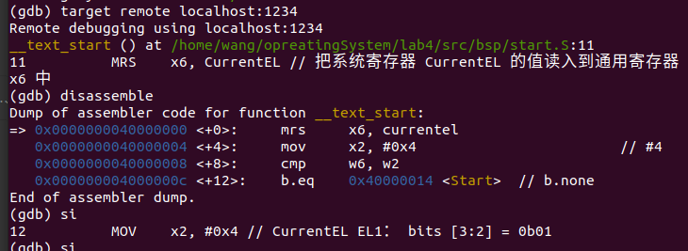

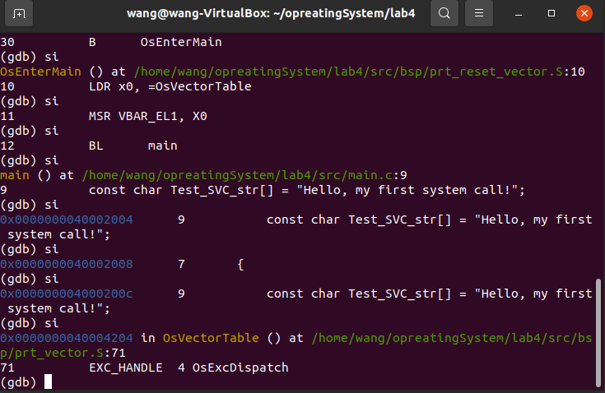





0001 1111 1110 0000 0000 0000 0000

Ctrl+a，x

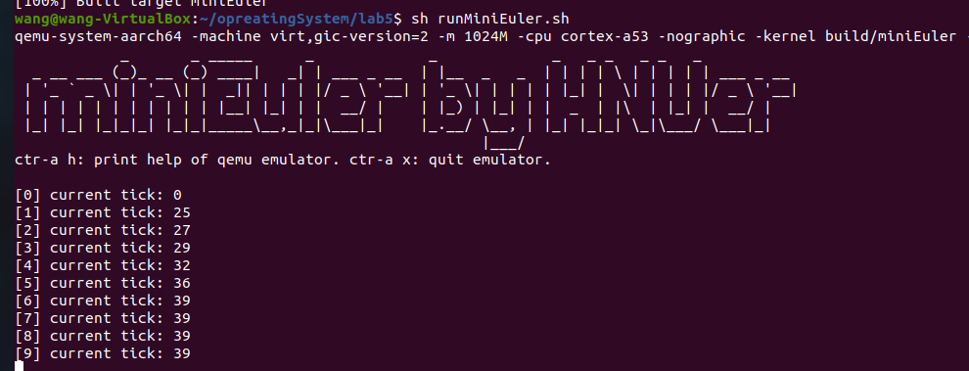

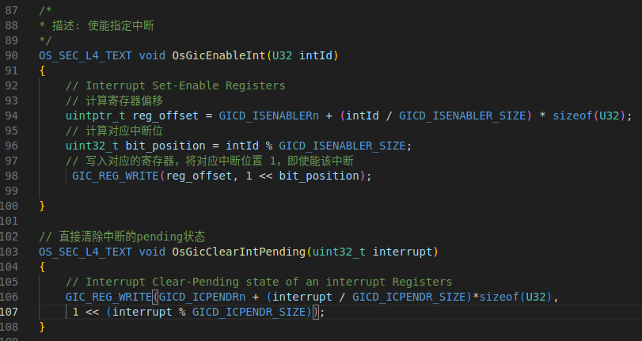

aarch64-none-elf-gdb build/miniEuler

localhost:1234

disassemble